Global GUI designs module E

Team S61E

Contents

Introduction 3

The GUI model 4

Lay-out standard 5

Anonymous User 6

0.1a Start screen 6

0.1a Register confirm 7

0.2 Register 8

0.3 Log In 8

Identified admin – all pages 9

1.1 Start 9

1.2 Pause 9

1.3 Freeze 9

1.4 Stop 9

2.1 Manage users 10

2.1.1 Manage participants 10

2.1.2 Register participant 11

2.1.3 Manage team 12

2.1.4 Register team 13

2.2 Manage game 13

2.2.1 Manage game - create 14

2.2.2 Manage game - current 15

2.3 Server info 16

3.1 Log out 16

# Introduction

This document contains the screen designs for module E. And to provide more structure a GUI model has also been made, which shows how all the pages are connected to each other.

These design mainly revolve around the functionality that has to reside within a page and which lay-out is most suitable for it. What isn’t a part of these designs are subjects like use of color and images when these are not essential to the functionality.

Each chapter revolves around a category of screen designs and is interlude by part of the GUI model. In doing this it becomes more clear which part of the model belongs to which screen designs.

# The GUI model

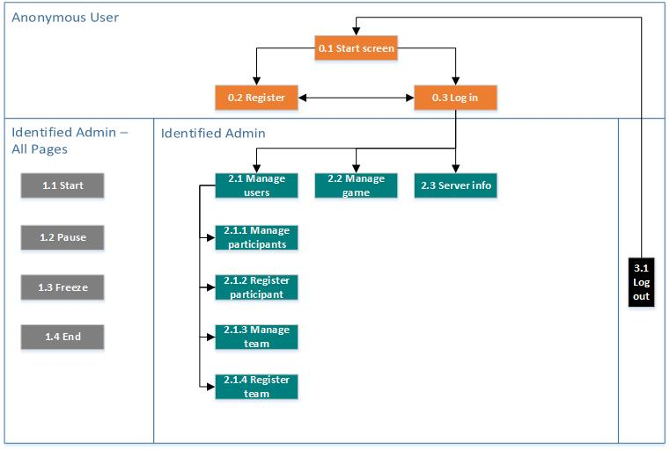

# Lay-out standard

In the following chapters each screen content is described. This lay-out standard describes what the entire page looks like.

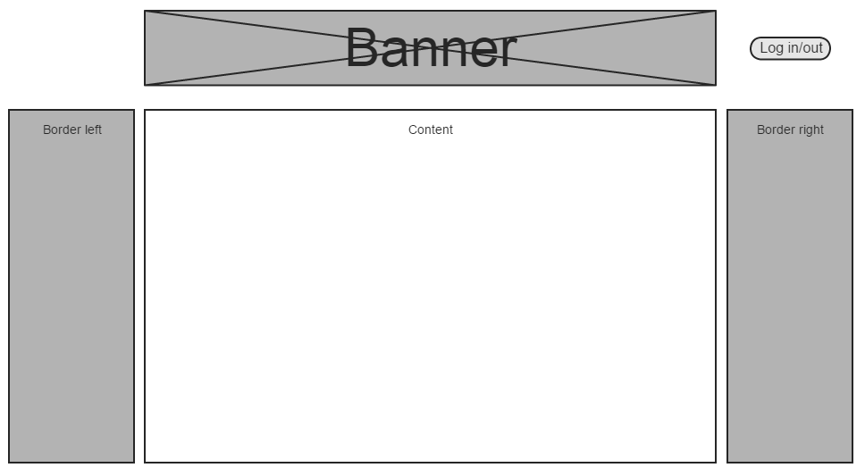

# Anonymous User

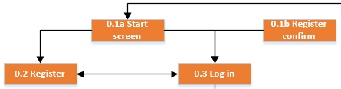

A user has to identify himself before he can participate in a competition. Before doing so he can only reach three screens. Because the functionality for these screens is pretty straight forward, the design itself has been kept simple.

## 0.1a Start screen

The welcome screen user see before identifying themselves.

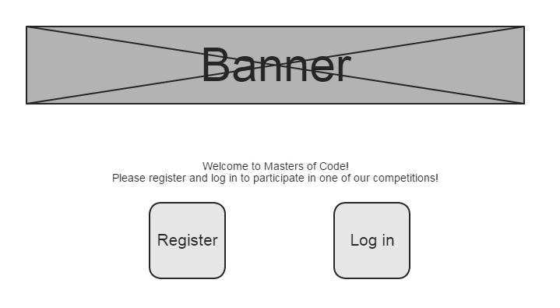

## 0.1a Register confirm

When the user registers himself he receives an e-mail with a link. By pressing the link he confirms that he wants to register and this screen is shown.

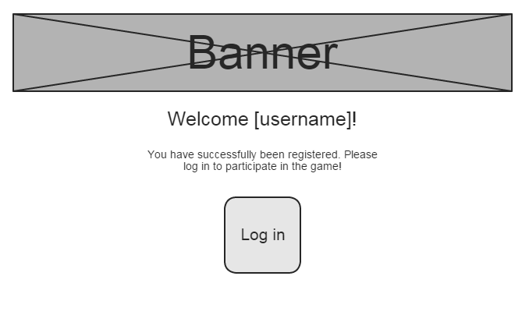

## 0.2 Register

Here users can register themselves so they can log in.

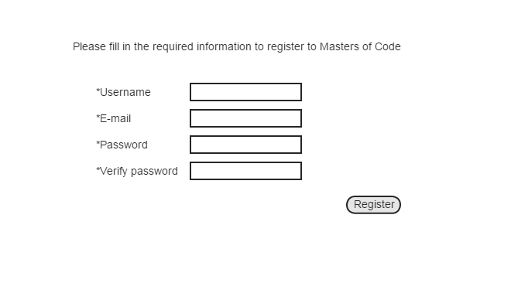

## 0.3 Log In

Here users can log in so they can participate in the game. They can reach the register screen via the “I don’t have an account yet” link.

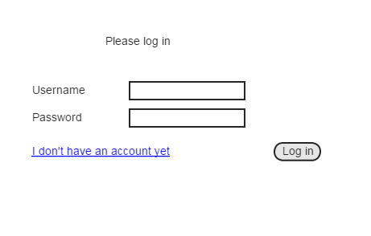

# Identified admin – all pages

The following four elements are not screens on their own, but buttons. We have decided to include them in the GUI model to emphasize that this functionality is available for an identified admin. The buttons will appear on all the identified admin pages as long as there is a current game. If there is currently no game going on they will not be visible or active.

## Start

There is a start button for the round and a start button for the game. By clicking on the start game button the game will start and by clicking on the start round button the round will start.

## Pause

By clicking on this button the round will pause, but participants can still access the client.

## Freeze

By clicking this button the round will freeze and participants will not be able to access the client.

## 1.4 Stop

There is a stop button for the round and a stop button for the game. By clicking on the stop game button the game will stop and by clicking on the stop round button the round will stop.

# 2.1 Manage users

Here the admin can manage the participants and the teams.

## 2.1.1 Manage participants

The admin can select a participant on the left and thereby show information about him on the right. For each participant the information can be edited. The screen design also shows the option to delete and ban the participant, this functionality is not part of the primary realization but is something we wish to implement if time allows it.

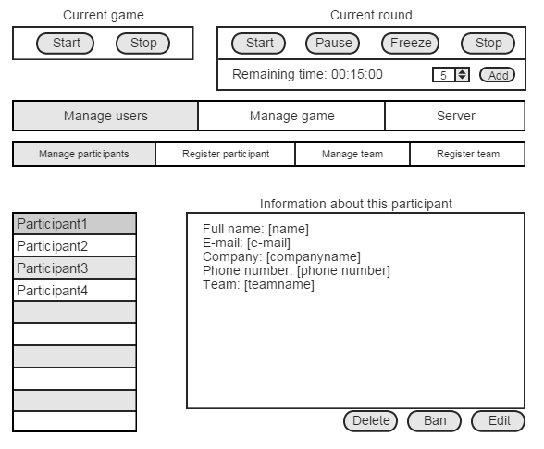

## 2.1.2 Register participant

The admin can register a participant by filling in the required information.

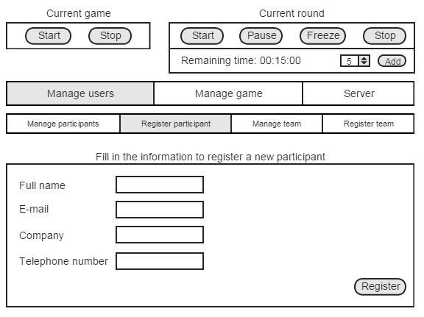

## 2.1.3 Manage team

The admin can edit and view the information about an existing team.

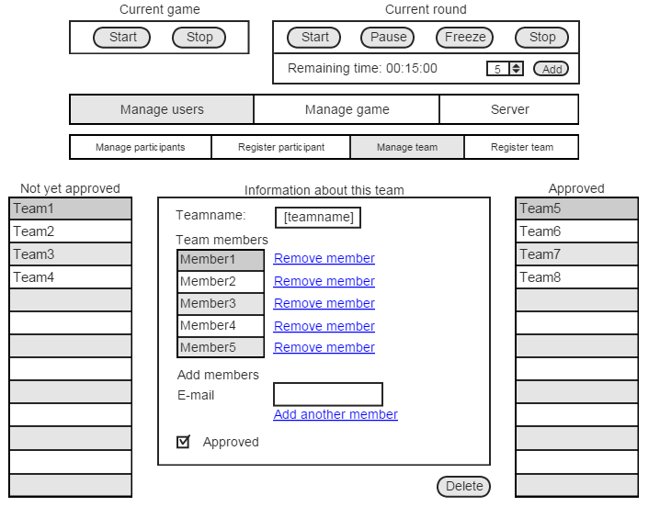

## 2.1.4 Register team

The admin can register a team by giving it a name and selecting the team members.

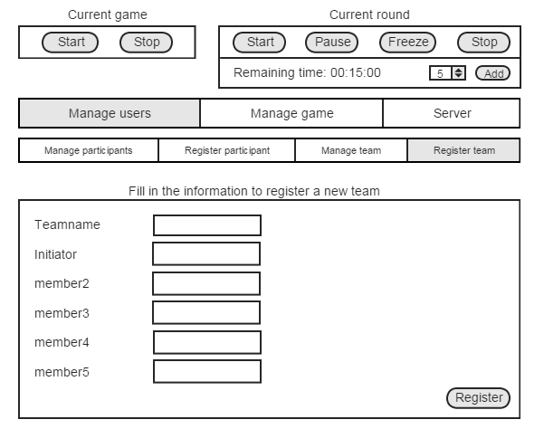

## 2.2 Manage game

When the admin clicks on this menu button he can be send to two different pages:

1. Create: when there is no current game the admin can create one
2. Current: when there is a current game the admin can view and configure it

### 2.2.1 Manage game - create

The admin can create a new game by providing the necessary information. He provides global information for the whole game, adds and configures rounds, and adds and configures hints. The order or the rounds can be configures with the minus and plus next to the round name.

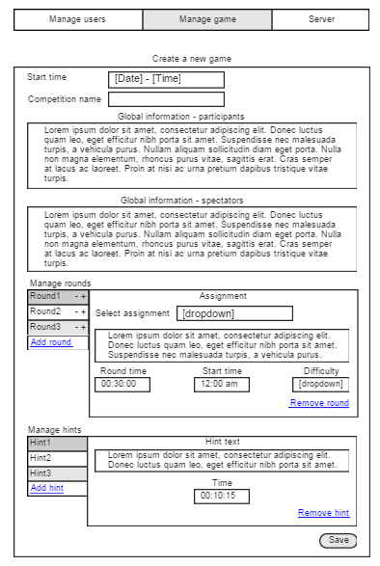

### 2.2.2 Manage game – current game

Once there is a game the admin can view its information. If there’s something he wants to change, for example if he wants to add to the remaining time, he can press the edit button, as long as the competition hasn’t started yet. He can then change the information that is shown and save his changes.

When the competition starts the ‘current game – current round’ bar becomes visible and screen 2.2.3 becomes available. At this time the edit button on this screen will be disabled.

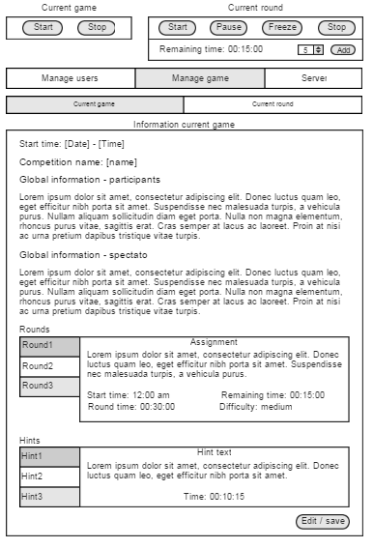

### 2.2.3 Manage game – current game

Once the game is started this screen becomes available.

Here the admin can configure information about the current round.

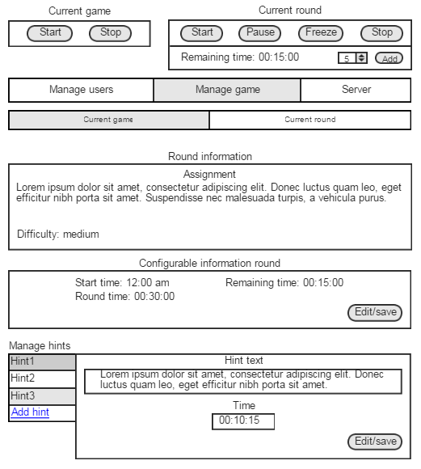

## 2.3 Server info

To give the admin some insight in how much the server is used some information is displayed on this screen.

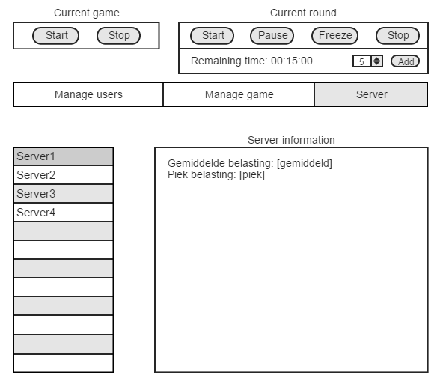

# 3.1 Log out

Technically this is not a screen, but since it is a functionality that is present on all the screens of the identified user it has still be included in the GUI model. Each screen has a “Log out” button that appears when the user hovers over the “My account” button. By clicking on it the user is unidentified once again and is redirected to screen “0.1 Start screen”.